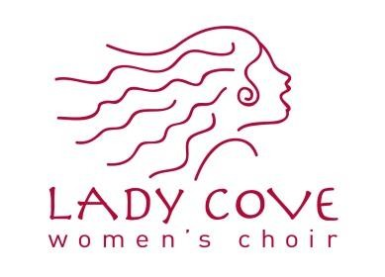

Lady Cove Choir Bursary

2021-22 APPLICATION FOR
THE LADY COVE CHOIR BURSARY
&
The Doctor Peggy Allan Armstrong Bursary

Deadline date February 25, 2022

Lady Cove Choir is pleased to offer the Lady Cove Choir Bursary, given annually in the amount of $1000 to a developing musician whose primary residence is Newfoundland and Labrador or who graduated from a Newfoundland and Labrador high school, in support of a music education experience. The bursary may be used for travel to a music program, participation in music festivals, lessons, private instruction, tuition or any other music education activity.

Interested musicians between the ages of 15 and 20 by December 31, 2021, should apply by completing and submitting the attached application form no later than Friday, February 25, 2022. The activities for which the Bursary is being sought must occur within sixteen months of the announcement of the Bursary recipient. The application must be supported by one written recommendation from the applicant’s music teacher/conductor.

The Doctor Peggy Allan Armstrong Bursary

In addition we are pleased to offer a second bursary, valued at $200, which is meant to encourage the next generation of young musicians who are building their experience and honing their craft. It is open to musicians between the ages
of 15 and 20 by December 31, 2021 who are striving to be their best. The activities for which the Bursary is being sought must occur within sixteen months of the announcement of the Bursary recipient. The application must be supported by one written recommendation from the applicant’s music teacher/conductor. The same application form and deadline
as the Lady Cove Choir Bursary will be used.

Applications

Applications will be reviewed by the Bursary Committee of the Lady Cove Choir, which is comprised of Choir and Board members, and community representatives. The winner will be notified before April 30, 2022. Recipients are required to demonstrate that the funds were used for the proposed activity. In the event the bursary cannot be used by the recipient, it should be returned to Lady Cove Choir. For this reason applicants should attempt to list more than one proposed activity on the bursary application.

The recipient of the bursary will receive a Form T4A slip reporting the amount paid.

Completed application and music teacher/conductor recommendation must be postmarked by February 25, 2022
and should be sent to:

By Mail:
Lady Cove Choir
141 Torbay Road
P.O. Box 21410
St. John’s, NL
A1A 5G6

OR

By Email:
contact@ladycove.ca

LADY COVE CHOIR BURSARY APPLICATION FORM (All applicants are considered for both bursaries. If you require additional space, please attach additional pages, not to exceed two type written pages)

NAME: | ADDRESS:
DATE OF BIRTH:
(day/month/year)
EMAIL:
PHONE:

DESCRIPTION OF ACTIVITY/IES:

DATE/S OF ACTIVITY/IES:

MUSICAL EXPERIENCE/ACHIEVEMENTS/BACKGROUND:

WHAT IMPACT WOULD RECEIVING THIS BURSARY HAVE ON YOUR MUSICAL DEVELOPMENT?

ESTIMATED EXPENSES: | Description | Amount
 |  | $
 |  | $
 |  | $
 |  | $
 | Total Expenses: | $

SIGNATURE OF APPLICANT: DATE OF APPLICATION:
(day/month/year)
Bursary recipients give Lady Cove Women’s Choir Inc. permission to use their name and photograph in promotion concerning the bursary and other choir activities.

